**GIT Hands-on**

**Name : Udit Bhargava**

**Superset Id : 6386801**

**Exercise 1 :**

**Objectives**

Familiar with Git commands like git init, git status, git add, git commit, git push, and git pull.

In this hands-on lab, you will learn how to

* Setup your machine with Git Configuration
* Integrate notepad++.exe to Git and make it a default editor
* Add a file to source code repository

**GIT Bash :**

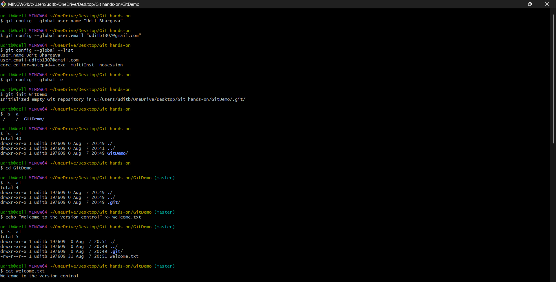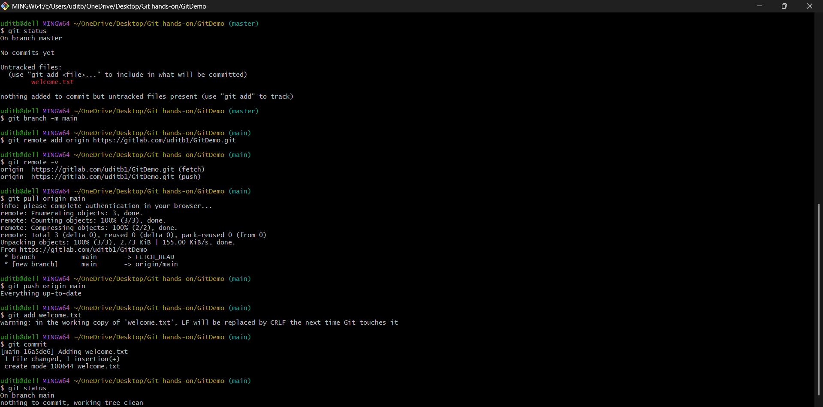

**Output :**

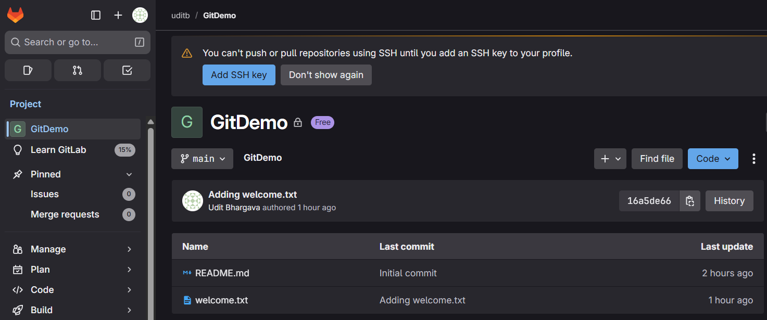

**Exercise 2 :**

**Objectives**

* Explain git ignore
* Explain how to ignore unwanted files using git ignore

In this hands-on lab, you will learn how to:

* Implement git ignore command to ignore unwanted files and folders

**GIT Bash :**

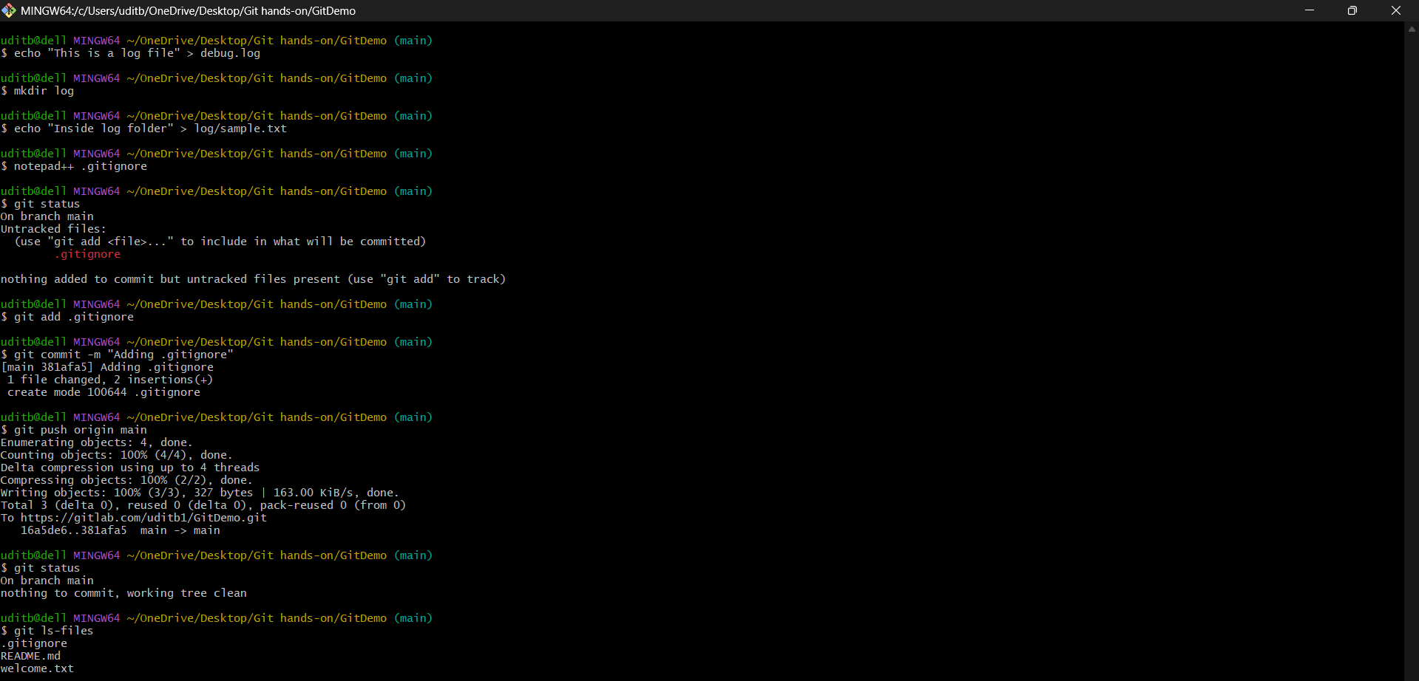

**Output :**

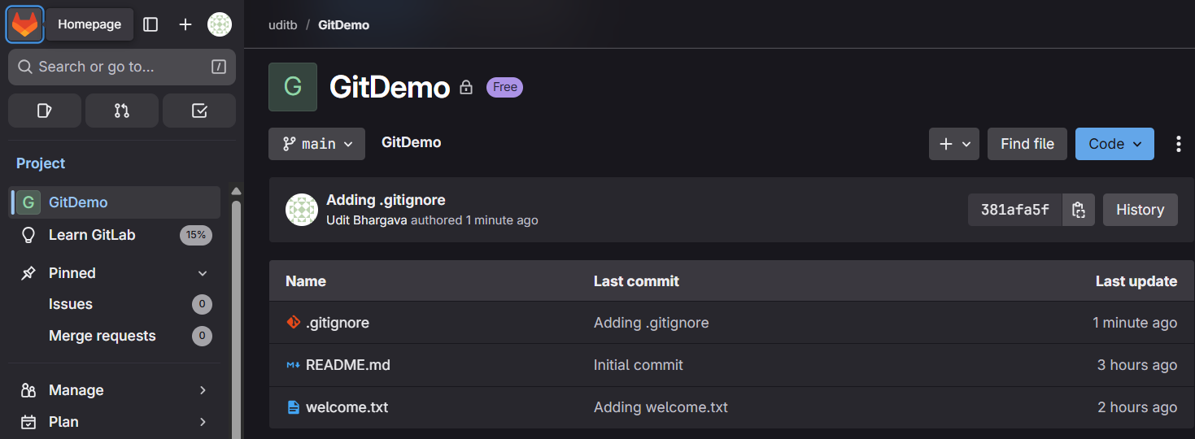

**Exercise 3 :**

**Objectives**

* Explain branching and merging
* Explain about creating a branch request in GitLab
* Explain about creating a merge request in GitLab

In this hands-on lab, you will learn how to:

* Construct a branch, do some changes in the branch, and merge it with master (or trunk)

**GIT Bash :**

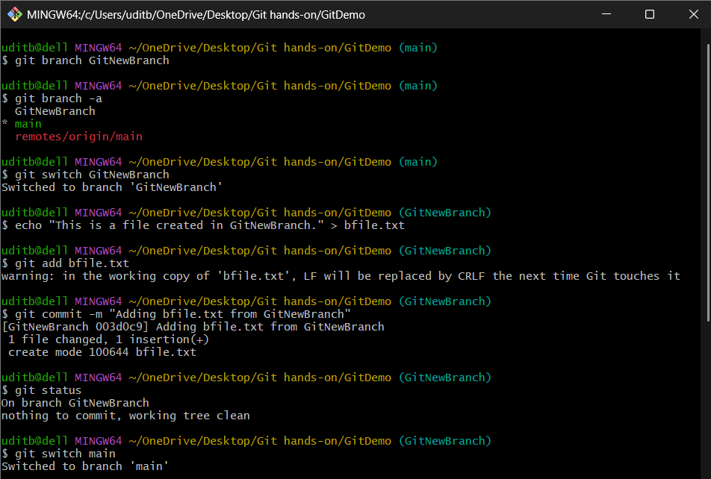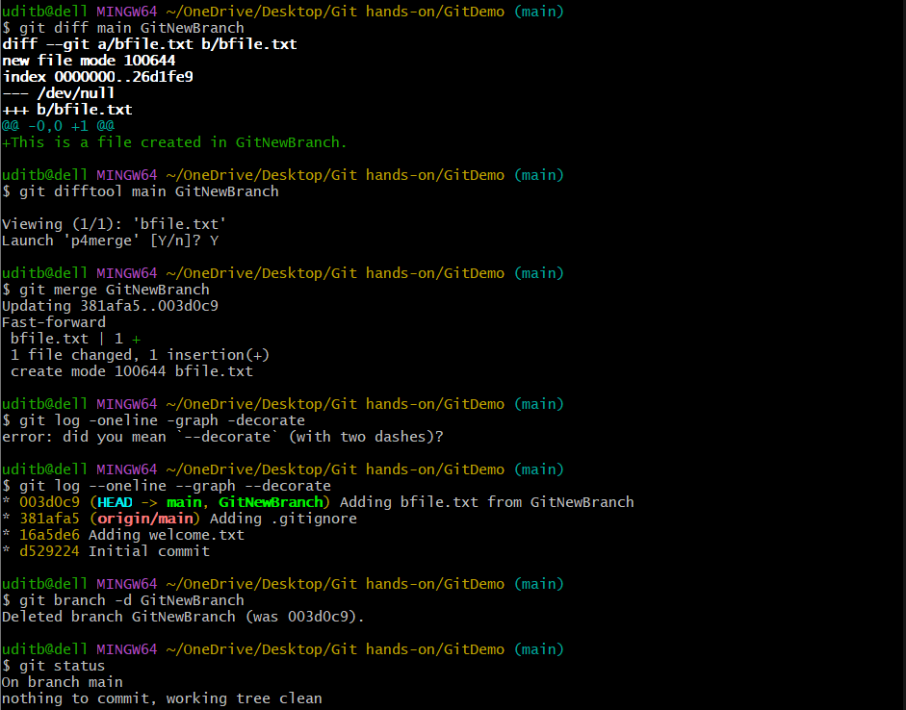

**Output :**

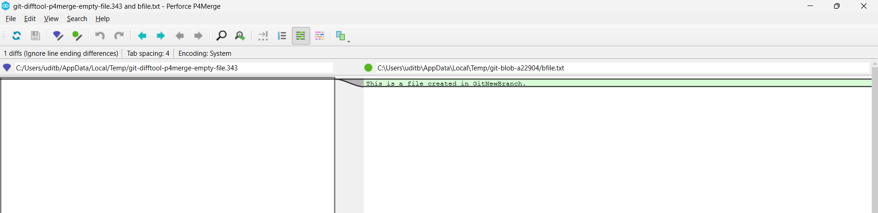

**Exercise 4 :**

**Objectives**

* Explain how to resolve the conflict during merge.

In this hands-on lab, you will learn how to:

* Implement conflict resolution when multiple users are updating the trunk (or master) in such a way that it results into a conflict with the branch’s modification.

**GIT Bash :**

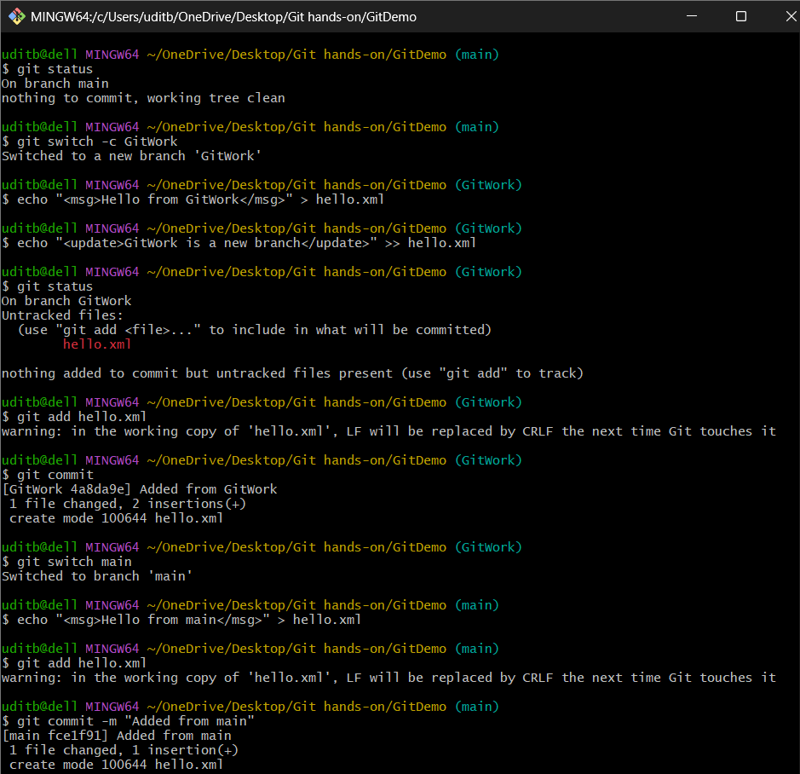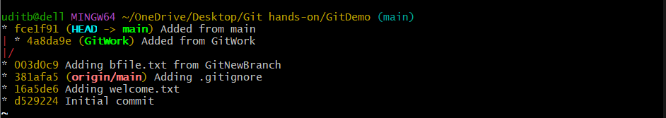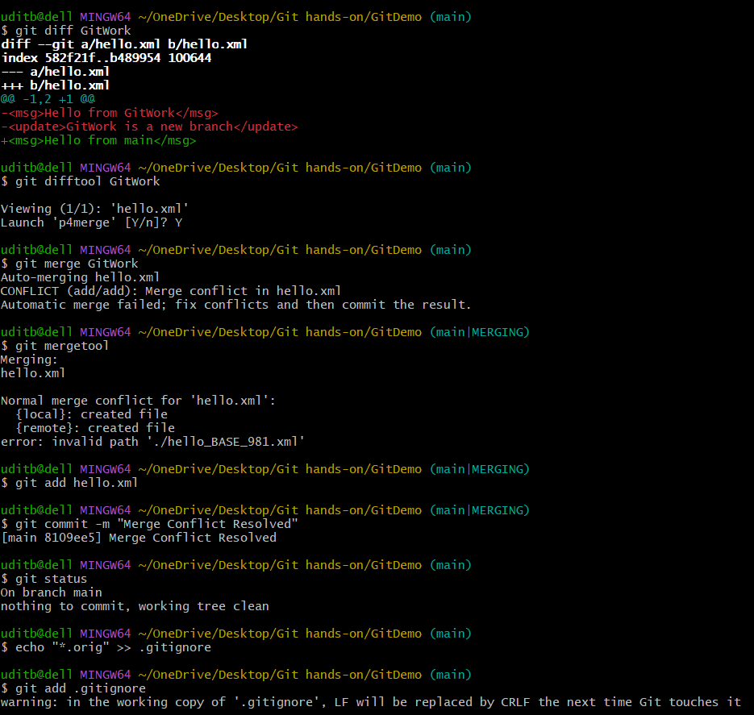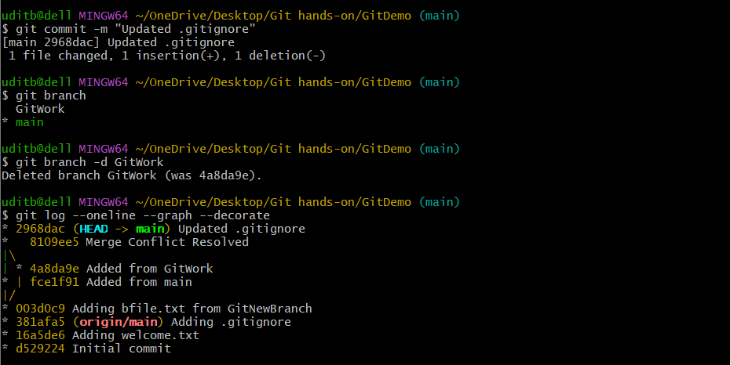

**Output :**

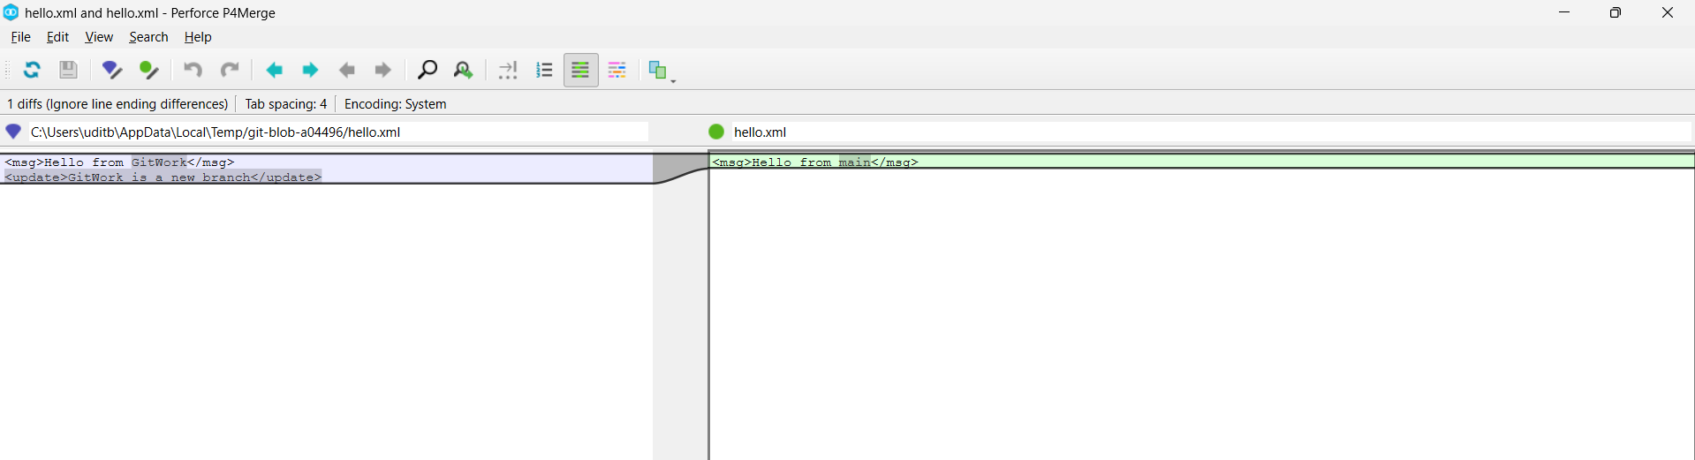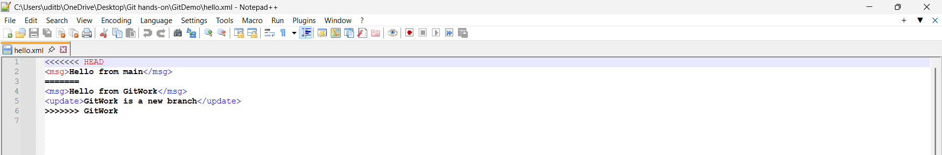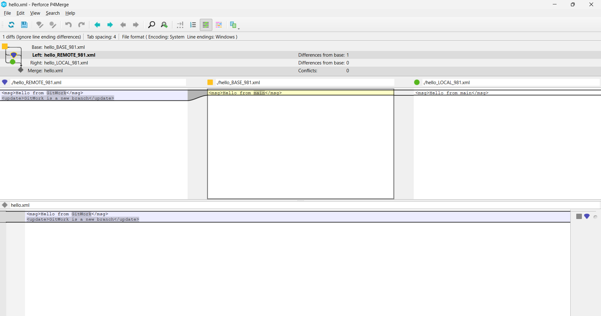

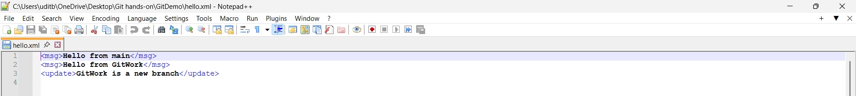

**Exercise 5 :**

**Objectives**

* Explain how to clean up and push back to remote Git

In this hands-on lab, you will learn how to:

* Execute steps involving clean up and push back to remote Git.

**GIT Bash :**

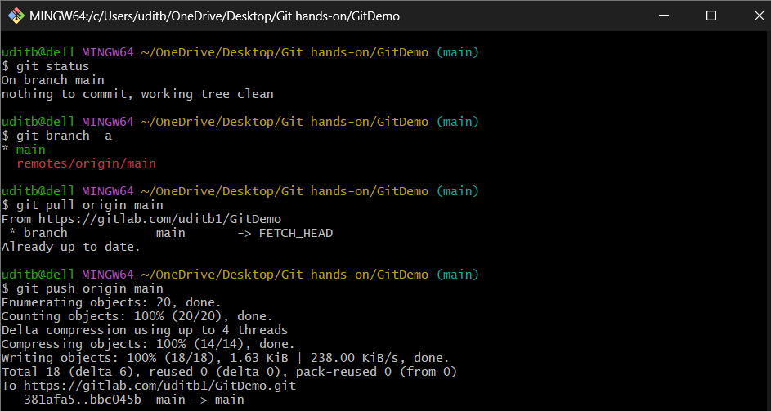

**Output :**

